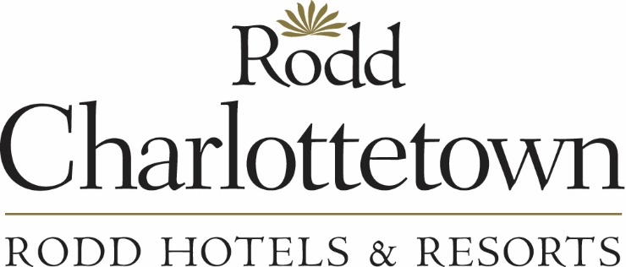

**Food & Beverage Server**

The Rodd Charlottetown Hotel is currently looking for servers and bartenders to join the food and beverage team.

**Position Summary:** As a food and beverage server at Rodd Charlottetown you may work in Main Dining Room, in Banquets or on the Bar. Your role will be to ensure a pleasant dining experience for our guests.  You will maintain a positive and respectful relationship with team members, engage with guests in a professional, dignified manner, and inform management of potential service and product issues before they arise. You will perform opening duties to prepare for service and closing duties at the end of your shift. You will employ sound judgment to establish whether to take guests’ food orders swiftly or to allow them time to relax.

**Skills, Abilities & Qualifications**

* must be 19 years of age or older to serve alcohol.
* Familiarity with handling cash, using POS systems
* Detail oriented, organized and efficient
* Have high quality of standards for service, customer service focused
* Strong verbal communication skills
* Be courteous and friendly, genuinely like interacting with people
* Good team player
* Be able to work independently with little supervision
* Be trustworthy and reliable
* Ability to adapt to change, think on your feet
* Be able to stand and walk short distances. Have the ability to handle, lift and move objects up to 20lbs over short distances. Bend, stoop, reach, push, pull and lift to perform routine job tasks.

Position is full-time or part-time, evenings and weekends.

To apply for this position please send a resume and cover letter to [hr@roddvacations.com](mailto:hr@roddvacations.com).

Salary: $14/hour plus gratuities.