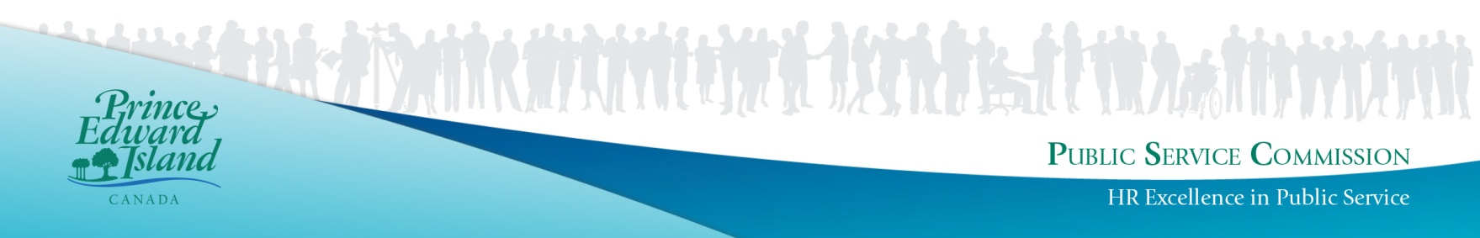

Open To Public
Junior Property Development Officer

Department of Agriculture and Land
Location – Charlottetown

Full-Time Temporary Position

(Term from May 2022- May 2023 with possible extension)
The PEI Department of Agriculture and Land aims to encourage the development of an innovative, diverse and inclusive workforce which enables the organization to realize its goals. The Junior Property Development Officer is a front line technical regulatory person for the daily administration and enforcement of the Planning Act (and Regulations), the Roads Act (Highway Access Regulations), the Lands Protection Act (Land Identification Regulations) and the Water Act (Sewage Disposal Systems Regulations). This position also evaluates proposals for subdivisions related to single lots for developments, highway access evaluation and audit sewage disposal systems documentation and installation. With these evaluations, the Junior Property Development Officer ensures that regulations and codes adopted for the protection of public health and safety and protection of the natural environment are assured and enforced.
Duties will include:
- Processing of applications for subdivision decisions, development permits, highway entrance-way permits and sewage disposal system permits;
- Interviewing applicants and providing advice, guidance and rational for legislation and regulatory requirements for all subdivision and development approvals;
- Providing technical interpretation of four sets of provincial regulations from four Provincial Acts;
- Researching and evaluating for all subdivision and development information required in the decision-making process.
- Conducting site inspection to evaluate site suitability for subdivision, development and sewage disposal systems;
- Preparing background information for regulation enforcement by notice, warnings and Summary Offence tickets, when required and preparing evidence for legal action under the Act and Regulations.
- Functioning as a Commissioner of Oaths and Deeds to facilitate Registering of legal documents as part of a mandatory registration of documents pursuant to the Road Act (Highway Access Regulations).
- Ensuring regulatory compliance with Provincial Regulations respecting on-site wastewater systems.
- Auditing of on-site disposal systems and liaison with appropriate parties concerning the construction and design of on-site systems as well as the enforcement of the Water Act, Sewage Disposal Systems Regulations.
- Investigating failures of on-site sewage systems in conjunction with other staff, as well as assessment of appropriate corrective measures for the protection of public health and safety.
- Preparing written reports on on-site sewage disposal systems investigations.
- Providing compliance and investigation support to other Department’s land use related issues on a case-by-case basis.
- Other duties as required.
Minimum Qualifications:
- Degree in Urban and Rural Planning supplemented with some experience in a related field or a certificate or diploma in Urban and Rural Planning supplemented with experience in a related field, as well as demonstrated additional course work in property law, presentations, surveying, resource and land use planning or geology
- General knowledge of the Planning Act Subdivision and Development Regulations, Water Act Sewage Disposal Systems Regulations, Roads Act Highway Access Regulations and Lands Protection Act Land Identification Regulations
- Working knowledge of computers, word processing and database programs.
- Eligible to be a Commissionaire of Deeds and Oaths for approval of Entrance Way Permits and Special Planning area lots
- Strong communication skills
Other Qualifications:
Basic understanding of the following would be considered an asset:
- IRAC Appeals Process
- Principles of design, operation and monitoring of wastewater services
- Subdivision and development approval process
- Administration and enforcement of regulations
- Gathering of evidence for warnings, summary offence tickets, appeals and court cases
- On-site sewage disposal systems including soil suitability and site evaluations
- Planning Act Subdivision and Development Regulations, Water Act Sewage Disposal Systems Regulations, Roads Act Highway Access Regulations and Lands Protection Act Land Identification Regulations

Note: Please ensure the application clearly demonstrates how you meet the noted qualifications as applicants will be screened based on the information provided. The successful candidate will be the only individual receiving written notification of competition results. The "Notification of Successful Candidates" list posted on the Employment Opportunity board will serve to inform all other applicants of competition results.

Salary Range: $24.27- $29.19 UPSE (level 12)
Bi-weekly hours: 75.0 hours bi-weekly
Posting ID#: 151370-0422ALTO
Closing Date: Monday, May 9, 2022 5:00 p.m.

Please return forms to PEI Public Service Commission, P.O. Box 2000, Charlottetown, Prince Edward Island, C1A 7N8. Applications may be sent by fax to (902-368-4383). IT IS THE RESPONSIBILITY OF THE APPLICANT TO CONFIRM RECEIPT OF THE APPLICATION BY TELEPHONE OR IN PERSON PRIOR TO THE CLOSING DATE. Please ensure that the appropriate Posting ID number is stated on all application forms. You can apply online or obtain an application form by visiting our web site at www.gov.pe.ca/jobs. Forms may also be obtained by contacting any PEI Government office, ACCESS PEI Centre, Regional Services Centre, or by telephone 368-4080.

