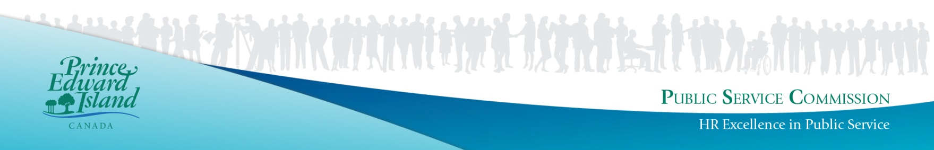
Open to the Public

Building Official

Department of Agriculture and Land
Location – Charlottetown

Full-Time Classified Position
(Commencing Immediately)
The PEI Department of Agriculture and Land aims to encourage the development of an innovative, diverse and inclusive workforce which enables the organization to realize its goals. In a regulatory environment, the Building Official is the front-line technical person responsible for the daily administration, interpretation and enforcement of the Building Codes Act/Regulations and the National Building Code of Canada. By performing construction plan reviews for compliance with building regulations and codes, issuing approvals or permits and completing inspections, the Building Official ensures that regulations and codes adopted for the public health, safety and fire protection in the construction of buildings are assured and enforced.
Duties will include:
- Processing applications and reviewing building plans and specifications for new buildings, renovations and/or alterations for compliance with building codes and regulations;
- Inspecting new building construction, additions and renovations to ensure compliance with building regulations and codes;
- Meeting with Architects, Engineers, Developers and Building Officials on technical code compliance issues;
- Preparing inspection reports and background information for orders and directives on violations and corrections;
- Subsequent to direction from the Department and Legal Counsel, representing and preparing cases for appeals and/or court cases;
- Maintaining records and files in hard copy and electronic format on unsightly properties and on applications of building proposals for compliance with building codes and regulations;
- Maintaining a high level of technical expertise in the interpretation of the Building Codes Act/Regulations, as well as the National Model Codes (National Building Code, National Fire Code and National Energy Code for Buildings);
- Interpreting and enforcing the Unsightly Property Act/Regulations to ensure properties are maintained in accordance with provincial legislation;
- Dealing with complaints and inquires on issues related to the administration of the Building Codes Act/Regulations and the National Building Code;
- Other duties as required.
Minimum Qualifications:
- Applicants must have Grade 12 or equivalent, supplemented by a university degree in Civil Engineering or Architecture or a two-year post-secondary diploma in a related field.
- Professional Engineering designation, licensed to practice in PEI, OR, a license to practice architecture in PEI, OR, a Residential Level Building Official Qualification (or greater) through a provincial, territorial or national association of building officials;
- Considerable relevant private sector experience working in the building construction industry;
- Considerable experience with the interpretation and application of the National Building Code;
- Considerable experience in the review of building plans and specifications;
- Experience in the preparation of briefing notes, reports, maintaining records and filing information in hard copy and database systems:
- Experience in the interpretation and enforcement of acts and regulation;
- Demonstrated equivalencies will be considered.
- Strong working knowledge of computers, word processing, spreadsheets and database programs;
- Strong organizational skills, excellent oral and written communication skills, and strong interpersonal skills to accommodate positive interactions with a wide variety of individuals in the construction trade;
- A valid driver’s license is required
- Applicant must have a good previous work and attendance record.
- The successful applicant must provide a satisfactory Criminal Records Check prior to commencing employment.
Other Qualifications:
- Red Seal Certification in Carpentry will be considered an asset.
- Additional relevant education and experience will be considered an asset.

Please Note: Please ensure the application clearly demonstrates how you meet the noted qualifications as applicants will be screened based on the information provided. The successful candidate will be the only individual receiving written notification of competition results. The "Notification of Successful Candidates" list posted on the Employment Opportunity board will serve to inform all other applicants of competition results.

Salary Range: $27.85- $33.15 per hour (Level 14 - UPSE)
Bi-Weekly Hours: 75.0 hours bi-weekly (evenings and weekends as required)
Posting ID: 150510-0222ALPO
Closing Date: Thursday, May 19, 2022 5:00 p.m.

Please return forms to PEI Public Service Commission, P.O. Box 2000, Charlottetown, Prince Edward Island, C1A 7N8. Applications may be sent by fax to (902) 368-4383. IT IS THE RESPONSIBILITY OF THE APPLICANT TO CONFIRM RECEIPT OF THE APPLICATION, BY TELEPHONE OR IN PERSON PRIOR TO THE CLOSING DATE. Please ensure that the appropriate Posting ID number is stated on all application forms. You can apply online or obtain an application form by visiting our web site at www.gov.pe.ca/jobs. Forms may also be obtained by contacting any PEI Government office, ACCESS PEI Centre, Regional Services Centre, or by telephone 368-4080.

