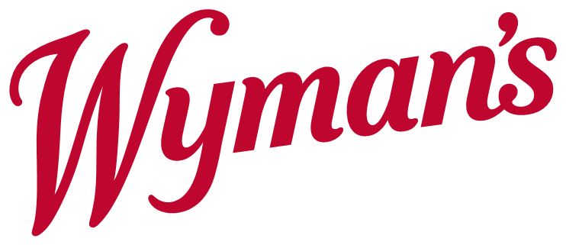

Jasper Wyman & Son, located in Morell, PE, is a leading grower, packager, and marketer of wild blueberries. We are seeking employees for our farm and processing facility to support the 2021 harvest season.

Farm Labourers/Tractor Operators

The successful candidates should have prior experience operating farm equipment, and able to do a variety of related tasks. Must be able to lift to 50lbs and be able to do physical labour. Candidates with experience operating farm equipment or mechanically inclined individuals are preferred. A Class 3 driver’s license is an asset.

Food Processing Labourers

Some positions available include general labourers, forklift drivers, quality control personnel, and building cleaners. Experience is not necessary for most positions.

The successful candidates should enjoy working in a fast-paced environment, doing repetitive tasks, and standing for extended periods. Transportation will be available from Charlottetown.

If interested, please send your resume to:
laxworthy@wymans.com or call Lori at 902-961-3330

